Airport CO₂ Emission Analysis

Final Report for Data Analytics Capstone
(Fall Semester, 2025)


Prepared by: Lieve Schalk
COMPSCIX490
Instructor: Roberto Bandeira de Mello Morais da Si

December 10, 2025
Table of Content
Contents
Executive Summary 3
Problem definition & Business Understanding 4
Data Source & Collection 4
Cloud Architecture Choice 5
Data Ingestion 5
Data cleaning 6
Exploratory Data Analysis (EDA) 8
Transformations / Modeling Layer 10
Dashboard 10
Insights & Interpretation 12
Recommendations 13
Project Limitations 14
Future work 14
Version Control & Reproducibility 15
Appendix 15

Executive Summary
CO₂ emission has become a major global concern, and the aviation industry is a significant contributor to this environmental challenge. Aviation accounts for 2.5% of global CO₂ emissions, but it has contributed around 4% to global warming to date (What share of global CO₂ emissions come from aviation? - Our World in Data).

It is the Federal Aviation Administration (FAA) job to control those CO₂ emissions and see what they can do to reduce the environmental impact of U.S. aviation. Not all airports and countries contribute equally to global aviation emissions—some locations show disproportionately high CO₂ output. Without clear, data-driven insights, it is difficult for policymakers to prioritize which airports, cities, or countries should receive sustainability funding or regulatory attention.

This project analyzes the emission from flights worldwide to see which countries and cities have the biggest CO₂ emission and therefore can benefit from efficiency improvements. The data for this analysis is drawn from two datasets. The first one is a flight-level dataset that contains more than one million records, including CO₂ emissions per flight, average emissions by route, origin and destination airports, airlines, and distances. This dataset is collected from Kaggle. The second dataset has data from the OpenFlights website. It provides airport locations, city information, and standardized identifiers like the IATA of an airport (3 letter code).

After this data was collected, the next step was to clean and restructure the raw data, and do an exploratory data analysis (EDA) to understand the dataset better and find global and US-specific patterns. This was performed in Python and then uploaded to BigQuery. In BigQuery transformations and aggregations were then done using SQL and some additional metrics were created, such as emissions per flight, intensity ratios, and comparisons between U.S. cities. Finally, as a final result those insights were visualized in Tableau on an interactive dashboard.

Key findings show that the United States stands out as the world’s largest contributor to aviation-related CO₂ emissions, driven by the high volume of flights operating across its major airports. These airports collectively account for a disproportionately large share of global aviation emissions. Interestingly, when comparing US airports by the average CO₂ emitted per flight, the variation is surprisingly small—most airports fall within a similar range of approximately 1.18 to 1.31 million kilograms per flight. This suggests that while total emissions differ from airport to airport due to traffic volume, the carbon footprint per individual flight remains relatively consistent across the network. Overall, the findings highlight that emission disparities are primarily driven by airport size and flight frequency rather than differences in per-flight efficiency. Based on these insights, the project recommends that the FAA should prioritize high-emission and high-intensity airports for sustainability initiatives. This could include the adoption of Sustainable Aviation Fuel (SAF), meanwhile it is also important to teach passengers about their CO₂ usages.

Problem definition & Business Understanding
Global warming is a big problem in today’s world, and CO₂ emissions is a big part of this. Air travel plays a major role in global CO₂ emissions, but not all airports contribute equally. Some airports produce far higher emissions because of the number of flights they handle, the length of routes they operate, or the efficiency of the airlines that use them. The main question this project addresses is: Which airports and countries contribute the most to aviation-related CO₂ emissions, and where should sustainability efforts be focused to achieve the biggest impact? This problem matters because aviation emission continues to grow each year and this makes it harder for governments to meet climate goals. It will be really helpful to understand where the emissions are concentrated to avoid wasting time and money on airports that are doing well already because they have low environmental impact. It is more important to identifying those that need urgent action. The key stakeholders include the Federal Aviation Administration (FAA) and environmental policymakers. Based on these findings, hopefully they will be able to make better decisions about which airports should be prioritized to help reduce their CO₂ emission.

Data Source & Collection
For this project, I used two main datasets that gave me a picture of global and U.S. aviation activity. The first dataset was a large flight-level emissions dataset containing over one million individual flight records. Each record included information such as the origin and destination airports, flight distance, aircraft carrier, and estimated CO₂ emissions per flight. This dataset was the core of the analysis because it directly measured the emissions I wanted to study. The second dataset came from OpenFlights, a publicly available database that provides detailed information about airports and airlines worldwide. This included helpful information like airport names, locations, city, and airport codes. This dataset was necessary because the flight dataset used airport codes, so I needed OpenFlights to match those codes with real geographic locations and countries.
Both datasets were stored as tables, which made them easy to work with in SQL and Python. The two sources were joinable because they shared the airport IATA codes, so this allowed me to enrich the emissions data with geographic context. The datasets were a good fit for the problem because the environmental impact (CO₂ emissions) from flights from all over the world were present, so this helped me identify high-impact airports and countries. They were both very accessible as the flight dataset was provided on Kaggle, and the OpenFlights data is openly available online. Together, the two datasets created a complete and feasible foundation for analyzing global emissions patterns and zooming in on the United States.

Cloud Architecture Choice
For this project, I used Google BigQuery, which is a cloud-based data warehouse designed for large-scale analytics. Because my dataset contained over one million flight records, BigQuery worked very well. It can store structured tables, run fast SQL queries, and handle heavy aggregation like CO₂ totals, country rankings, and airport-level calculations without performance issues. Using SQL inside BigQuery made it easy to clean, filter, join, and transform the data before building the BI dashboard. In a real industry setting, a data warehouse like BigQuery is ideal when the data is highly structured, regularly queried, and needs to support dashboards or reporting. The cost is also a benefit of this, as organizations only have to pay for the storage and compute they actually use. This keeps the cost manageable and efficient while still allowing teams to analyze very large datasets.

Although I did not use a Data Lake, it is an important architecture to mention. A data lake stores raw, unstructured data at low cost, which makes it useful for teams that need flexibility to ingest logs, text, images, or semi-structured files. However, my project relied heavily on structured relational data (airports, flights, CO₂ calculations), so a data lake would not have added meaningful advantages.
I also did not need a Lakehouse architecture. A lakehouse combines the flexibility of a data lake with the structure of a warehouse. It is a great option when a project mixes raw data science workloads with business intelligence dashboards on top. In this case, because my data was already clean, structured, and intended for SQL analytics, a traditional warehouse (BigQuery) was the most efficient and cost-effective option. This environment fully supported the transformations needed for my final analysis and visualization. Overall, using BigQuery was both practical for the project and aligned with how companies would handle similar aviation-emissions analytics at scale.

Data Ingestion
To begin the project, I first uploaded the data manually by loading two large CSV files into Google Colab and working with them in Python. This allowed me to explore the structure of the datasets, preview the fields, and start basic cleaning. After that I wanted to upload those updated CVS files into BigQuery,
however, when I tried to upload them, I ran into a size limitation. BigQuery only allows direct CSV uploads up to 100MB, and my flight dataset was much larger. Because of this, I shifted to a more scalable approach by using Google Cloud Storage (GCS). I uploaded the files into a GCS bucket and then imported them from GCS into BigQuery. This approach not only solved my size issue but also matched real-world data engineering practices, because they use cloud storage for large or frequently updated data.
In a real production environment, this project would benefit from programmatic ingestion rather than manual uploads. Tools like Airbyte, Fivetran, or custom API pipelines would be appropriate because flight and airport datasets can easily grow into millions of rows and need regular updates. Automated ingestion would ensure that data arrives consistently without manual steps. This will reduces human error, and supports scheduled refreshes. Those programmatic tools would make the system more reliable, scalable, and operationally efficient.

Data cleaning
Cleaning the data was a very important stage of this project. The combined flight dataset contained around 1.3 million rows, while the airport dataset contained several thousand unique airport entries from around the world. Since these two sources were eventually joined together for analysis, I needed to make sure they were consistent, complete enough for reliable insights, and properly formatted for BigQuery. The goal of this cleaning phase was not just to “fix errors,” but to understand the structure and limitations of the data so that later steps—like aggregations, CO₂ calculations, and BI visualization—would be accurate.
One of the first issues I investigated was missing values, which were common in several fields. The most noticeable missing field was aircraft_type, as it has a total of 13914 missing values. Since there was no way to replace those missing values (I wasn’t going to guess what aircraft was flying) and the aircraft-level CO₂ was not essential to my analysis, I made the decision to drop this whole column.
Another group of missing values appeared in avg_co2_emission_for_this_route and co2_percentage. These two fields had a large number of missing records—over 88,000 each—and importantly, they always appeared missing together. This pattern reveals something meaningful about how the original data was generated: these fields depend on having a route-level reference value. I decided that it was too big of a percentage of missing data to use this in my analysis, so instead, I relied on co2_emissions (the actual estimated CO₂ output of the specific flight) as the primary and most reliable measure for analysis. This was appropriate because co2_emissions was available in almost every row and represents the concrete value needed for city- and country-level aggregation. The rows that missed their co2_emissions (2% of the rows) were dropped because this value was the most important for my analysis and without it the row became useless. I did consider replacing the missing value by an average, but in my opining that would have made the results less accurate, and the data set was already large enough that removing those rows has no negative impact on the aggregated CO₂ calculations.
A smaller portion of missing data appeared in the city column, which comes from joining the flight dataset with airport information. Some airports either lacked a city field or contained alternative spellings or formatting inconsistencies. Since the analysis ultimately focuses on country-level aggregation, and only US cities, I checked if all the US cities where correct and decided that the others were not necessary for grouping flights geographically, so I chose to just leave these missing values in place. They add no risk to the analysis and may still contain helpful information for descriptive statistics.

After reviewing missing values, I also considered whether duplicates were an issue. With more than one million rows, it is normal for many flights to appear multiple times, because the dataset represents real-world flight activity. Routes are flown every day, and sometimes multiple times per day. For this reason, I did not remove duplicates. Even if two rows look identical, they still represent separate flight events that produce their own CO₂ emissions. Removing them would artificially reduce total emissions and distort the analysis. In this context, duplicates are not errors, so I kept all rows to preserve the true scale of CO₂ output.

Next, I standardized the data types, which was necessary because the dataset started in CSV format, then went into Python, and finally into BigQuery. When I first loaded the raw files, many of the numeric fields (like distance_km, co2_emissions, and avg_price) were still stored as text strings. I converted these into proper numeric types so I could run calculations, summaries, and aggregations without errors. I also cleaned all date-related fields by turning inconsistent date strings and timestamps into a standard date or datetime format, depending on what I needed later for analysis. For attributes such as airport codes and country names, I kept them as strings but standardized the formatting (for example, converting codes to uppercase) to make sure the join with the OpenFlights dataset worked smoothly.

To illustrate the cleaning process, here are simplified before/after examples:
Before cleaning:
- distance_km = "1540.0" (string instead of number)
- co2_emissions = "" (empty field)
- aircraft_type = None
- avg_co2_emission_for_this_route = ""
- city = "SAN FRANCISCO " (extra whitespace)
After cleaning:
- distance_km = 1540.0 (numeric)
- co2_emissions = row removed
- aircraft_type = column removed
- avg_co2_emission_for_this_route = NULL
- city = "San Francisco" (case-normalized, whitespace removed)

Overall, the cleaning process transformed two raw, inconsistent datasets into a stable foundation for analysis in BigQuery and Looker Studio. By carefully handling missing values, normalizing formats, removing only truly problematic rows, and documenting all decisions, the dataset became trustworthy and ready for KPI creation, modeling, and dashboard visualization.

Exploratory Data Analysis (EDA)
To start exploring the data, I used Python to look at basic distributions and overall patterns in the flight-level variables, especially CO₂ emissions. First, I plotted the distribution of CO₂ emissions for all flights. The histogram showed a heavily right-skewed pattern: most flights produce relatively moderate amounts of CO₂, but there is a long tail with some extremely high-emission flights. These outliers make sense because certain long-haul international routes naturally generate much larger carbon footprints. This visualization helped confirm that the data contains a wide variety of flight distances and aircraft types, which contributes to the spread.
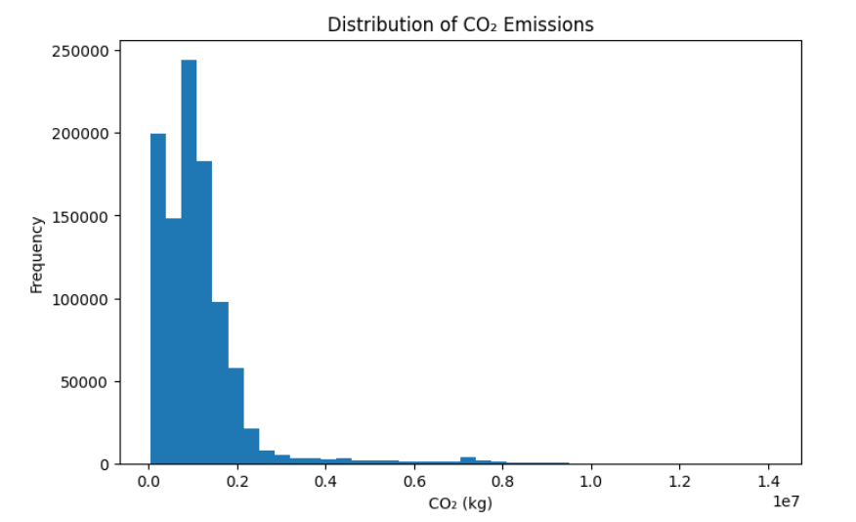

Next, I created a scatter plot comparing ticket price and CO₂ emissions. While the graph was dense, a few patterns stood out. There was no clear linear relationship between how expensive a flight is and how much CO₂ it produces. Instead, cheaper flights could still have high emissions, and more expensive flights could have lower emissions. This suggests that price is not a reliable indicator of sustainability, and that emissions are driven more by route characteristics (such as distance and stops) than by cost. I do think this is very interesting because in my opinion a higher CO₂ emission should result in paying more for the flight.
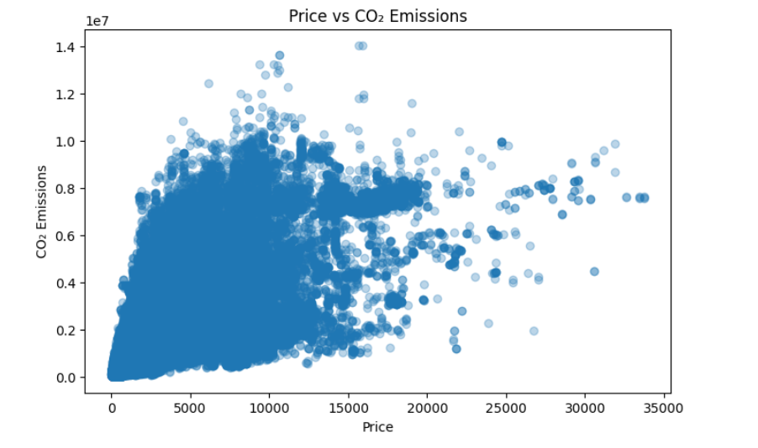

Finally, I used Python to aggregate emissions by destination country and visualized the top 10. This bar chart showed a clear imbalance: the United States had the highest total CO₂ emissions in the dataset by a large margin, followed by Australia, India, the United Kingdom, and Brazil. Overall, the Python EDA step gave me a first look at the distribution of emissions, potential outliers, and initial hypotheses about what drives high-impact routes.

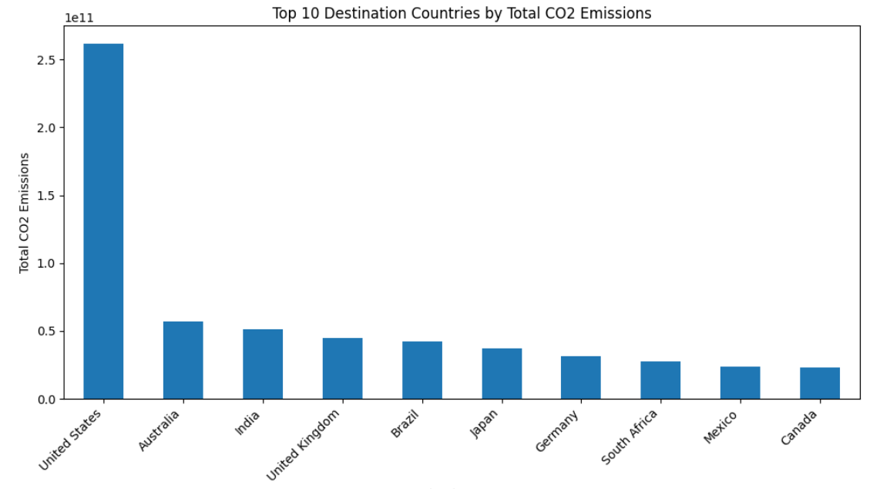

Transformations / Modeling Layer
For the transformation layer, I primarily used SQL in BigQuery, which was the preferred option for this project. After loading the cleaned dataset into BigQuery, I began creating smaller, purpose-built tables that would help me better for the visualizations I wanted to build later. Instead of querying the large raw table each time, I broke the data into targeted, analytical tables that focused on specific questions.
I created tables that summarize emissions at the country and city level. This made it straightforward to plug that table directly into a bar chart later without having to rebuild the logic in the visualization tool. I used GROUP BY logic to compute total emissions per destination country, as well as per origin or destination city. Throughout the transformation process, my goal was to structure the data in a way that supported the narrative of the analysis: which countries pollute the most and which cities are associated with higher-emission routes, and how emissions vary by country. After I generated these aggregated results in BigQuery, I exported the query outputs into Google Sheets. The Sheets layer acted as a final lightweight cleaning and preparation step before building visuals. Some columns still needed some additional work—for example, in certain rows the airline field contained paired airline values in the format [Lufthansa | United]. I decided to treat the first airline as the primary carrier, assuming it represented the operating airline. I standardized these values, so each row reflected only one airline. Once this was cleaned, I could build reliable pivot tables in Sheets such as total CO₂ emissions per airline (which I eventually did not use in my dashboard haha) and CO₂ emissions per country and city, but for the total CO₂ (sum) and the intensity (sum/number of flights). After that I was able to use those tables for my visualizations.

Dashboard
For the BI layer, I built an interactive dashboard in Tableau, since it allowed me to combine multiple tables, and design a layout that clearly communicates the key CO₂ insights from the flight dataset. I structured the dashboard so that it immediately gives an overview of the most important metrics.
On the top of the dashboard, I highlighted the main KPIs I derived from my cleaned and transformed tables. Those include:
- Total global CO₂ emissions
- Top 3 countries by total CO₂
- Highest-emission U.S. city
- Highest per-flight CO₂ intensity U.S. city

These metrics appear at the top of the dashboard so the viewer understands the scale of the emissions problem before diving into the visuals. Underneath the KPIs, I added world and U.S. maps that show emissions geographically. The size and color of each bubble helps users immediately spot the biggest emission hotspots. Next to the maps I added bar charts to see the difference in countries/cities. These charts use consistent formatting so they’re easy to compare. The visuals were driven directly from the smaller summary tables I created in BigQuery (such as the airline CO₂ ranking table and the country/city aggregate tables), which made the dashboard load quickly and reduced the amount of heavy processing Tableau needed to do.
To make the dashboard more dynamic, I added filters that allow the viewer to interact with the data—such as selecting countries, or individual cities, so that it is easier to find certain data if someone is looking for something specific.

The screenshots below show the final layout of the Tableau dashboard.

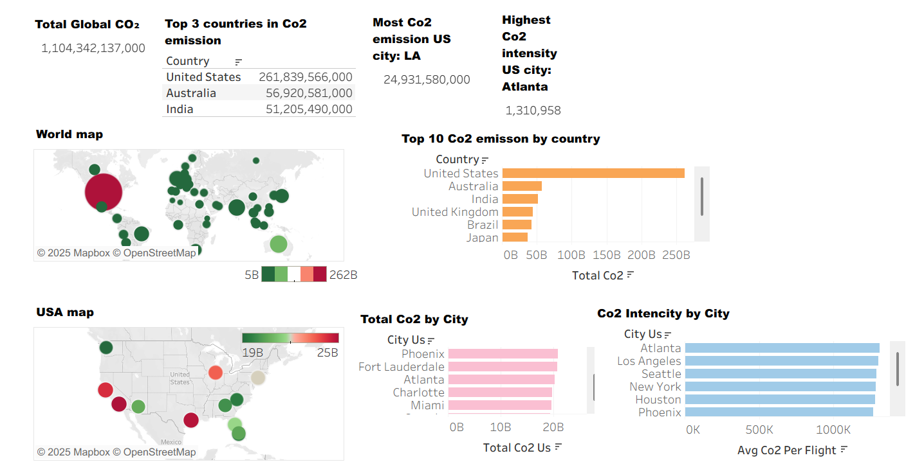

Insights & Interpretation
When I pulled everything together on the dashboard and looked at the full CO₂ picture across countries and cities a few things became very clear. First, the data shows that aviation emissions are very concentrated. A small number of countries and major hub cities account for a huge share of total global aviation CO₂. The United States alone produced far more aviation-related CO₂ than any other country in the dataset. This makes sense because it has many of the world’s busiest airports, but actually seeing the scale of the difference was eye-opening. It confirms that if we want to make meaningful progress toward reducing aviation emissions, it is important to focus on the biggest markets as this will have the strongest impact.
Looking at cities, the results were similar. Los Angeles came out as the highest-emission US city, which wasn’t too surprising given the amount of long-haul traffic that moves through LAX. What did catch my attention was how many other US cities also contribute substantial emissions—Houston, San Francisco, Chicago, and New York were all high as well. This shows that emissions aren’t just coming from one “mega contributor,” but from multiple that collectively drive a large portion of total CO₂.
One thing that really surprised me was the CO₂ intensity per flight. When I calculated intensity (total CO₂ divided by number of flights), the values across major US cities were almost the same. The most intense city was Atlanta at around 1.31 million, and the lowest was Phoenix at 1.18 million. I think that’s a very narrow range considering how different the airports are in size and traffic type. To me, this suggests that there are already industry-wide regulations, aircraft standards, and fuel-efficiency expectations shaping how airlines operate. In other words, even though the volumes of flights vary massively, the average emissions per flight stay surprisingly consistent. This is actually a positive sign as it means the system is not completely inefficient or out of control. But at the same time, the intensity numbers are still very high, and there is definitely room for improvement.
For stakeholders, the most important insight is that emission-reduction strategies should focus on the biggest contributors first. Large airports and countries with the highest traffic should be the primary targets for sustainability programs because changes there will have the largest global impact. For example, policies such as cleaner fuels, optimized flight routing, and stricter reporting requirements would make a much bigger difference if implemented in large hubs like LAX, ATL, SFO, or major European and Asian hubs.
Another key point is that reducing overall flight volume is a crucial lever. Since intensity per flight is relatively stable, the main way to significantly cut emissions is to decrease the number of high-emission flights or shift them toward more efficient aircraft or alternative fuels.

How the insights tie back to the original business problem
The main question was:
Which airports and countries contribute the most to aviation-related CO₂ emissions, and where should sustainability efforts be focused to achieve the biggest impact?
Based on the analysis:
- Top contributors are clearly identified
- Emissions are concentrated, meaning we don’t need to target every airport equally.
- The stability of CO₂ intensity suggests that technological improvements and stricter standards could make a meaningful difference across all flights.
- Sustainability efforts should focus on high-volume places, because that’s where the emissions are largest.

Recommendations
- Prioritize sustainability initiatives in high-traffic hubs such as LAX, ATL, SFO, and JFK.
These airports handle millions of passengers and an enormous number of flights each year. Because of that scale, even a small improvement can result in huge reductions in global CO₂. Focusing on these major airports will have a bigger impact.

- Optimize operations on long-haul routes, where emissions are naturally the highest.
Long-haul flights account for a big share of emissions, so increasing efficiency here has a major impact. Improvements like better route planning and updated navigation technology should not be too hard to make.

- Support the expansion and adoption of Sustainable Aviation Fuel (SAF), especially at the largest airports.
Sustainable Aviation Fuel (SAF) is a cleaner alternative to traditional jet fuel. It is made from renewable sources like used cooking oil, agricultural waste, or other non-fossil feedstocks. It can be used in today’s aircraft with little or no modification, and although it doesn’t eliminate emissions completely, it can significantly reduce lifecycle CO₂ output compared to conventional fuel (What is sustainable aviation fuel and how is it made? | World Economic Forum)

- Increase awareness among travelers and companies about the CO₂ impact of long-distance flights.
Educating people doesn’t mean discouraging travel, but it is important to teach them more and help them make informed decisions. This awareness can reduce unnecessary travel or shift trips to lower-emission options and those small behavior changes can make a real difference.

Overall, the data paints a clear picture: substantial CO₂ reductions are possible, but only if efforts are targeted where the emissions actually come from and we are willing to make changes. By focusing on the major hubs and the largest markets, stakeholders can make meaningful progress toward a more sustainable aviation sector.

Project Limitations
This analysis came with several limitations that are important to acknowledge. First, the dataset itself was not fully complete. One of the biggest gaps was that it did not contain any records of flights originating from the United States—only flights arriving in the U.S. This means that the total CO₂ impact of U.S. airports is underreported, because outbound emissions were simply missing. As a result, airports like LAX, JFK, and SFO likely emit much more than what the dataset allowed me to measure.

Another limitation is related to bias. Because the dataset only included flights from a specific timeframe (although this is not mentioned on Kaggle so I have no clue what the timeframe is), the results might not represent long-term or year-round trends. Additionally, some regions had much better coverage than others, which could skew the ranking of countries and airports.
On the modeling side, I relied heavily on aggregate CO₂ values provided in the dataset rather than building a predictive emissions model myself. This means my analysis is only as accurate as the original calculations done by the data provider. The architecture choices also introduced constraints: since the raw data came in via CSV uploads and later moved into BigQuery, there were some challenges around data type conversions. Despite these limitations, the dataset still gave a strong enough signal to identify major emission hotspots and highlight where sustainability efforts could have the greatest impact.

Future work
There are several ways this project could be improved or expanded in the future. One of the most important next steps would be to include additional data sources, such as U.S. Department of Transportation flight records or airline fuel-burn reports. Adding these sources would give a more complete picture of global aviation emissions and help fill some of the current gaps—especially the missing U.S. origin flights.
Another major improvement would be to set up a programmatic data pipeline instead of relying on manual CSV uploads. Tools like Airbyte, Fivetran, or direct API ingestion could automatically bring in fresh flight data on a daily or hourly basis. This would make the system more reliable and allow the dashboard to stay updated without manual effort.
On the analytics side, more advanced modeling could be introduced. For example, forecasting models could estimate the expected CO₂ emissions for future months, or simulations could show how emissions might change if airports increased SAF adoption.
Finally, the BI dashboard could be improved with more interactivity and deeper drill-downs. Adding trend views, dynamic filters, or route-level breakdowns would make the dashboard even more useful for decision-makers. Over time, this project could evolve into a full emissions-monitoring system for airports, airlines, or policymakers.

Version Control & Reproducibility
Version control ensured that every change in the project was tracked, which makes it easy to see what was updated and when. It also improves reproducibility, because anyone can access the exact code and data used to create the results. To support this, my entire project will be stored and maintained in GitHub so it can be easily shared, reviewed, and reproduced.

Appendix
All code (phyton script, sql) transformations, visualizations, and additional project files are available in the GitHub repository:
https://github.com/lieve-schalk/Capstone-.git
This repository contains all technical details that support the analysis presented in the main report.

